Complete the following problems from Chapter 3:
- P3-3
- P3-6
- P3-10
- P3-16
- P3-18
- P3-20
- P3-21
Follow these instructions for completing and submitting your assignment:
- Please do all work in Excel. Do not submit Word files or *.pdf files.
- Submit a single spreadsheet file for this assignment. Do not submit multiple files.
- Place each problem on a separate spreadsheet tab.
- Label all inputs and outputs and highlight your final answer.
- Follow the directions in “Guidelines for Developing Spreadsheets.”

Guidelines for Developing Spreadsheets

It is important to develop spreadsheets that are clear, well-organized, and easy to read. Here are some tips that you will need to assist with your assignments in class. I recommend them for all your work, both at GCU and later in your career.

- Your spreadsheet should be organized into three basic parts. Clearly label each part.
  - A title, labeling what your spreadsheet does. The title for your spreadsheets in this course can be the problem number that you are assigned. Place this in the upper left corner, in cell A1.
  - Inputs, which are given or assumed.
  - Results (Outputs) which the spreadsheet calculates.
- Provide specific labels for all inputs and outputs. Label both the variable names and the notation for the variables. Where a formula is involved, it is a good idea (but not necessary) to enter the formula to the right of the cell containing the results. I display these formulas in italics, so that they are not confused with the variable labels.
- Highlight the cell containing the final answer, using EXCEL’s yellow highlighter, which can be found on the top menu bar.
- If your spreadsheet uses a long formula, you might find it advisable to break the formula into component parts. This serves to minimize the typos that can occur when entering long formulas, as well as makes locating errors in the results easier to find. Nested parentheses are a particular problem in long formulas, and breaking up the calculations into component parts minimizes the need for nested parentheses also. In the example below, the calculations are broken into two steps; (1) the percentage changes in price and quantity demanded, and (2) the final elasticity calculation using these intermediate results.
- Don’t forget to place each homework problem on a separate spreadsheet tab. Label these tabs with the problem number for easy identification.

A sample spreadsheet reflecting these points is below.

Calculating Price Elasticity of Demand
Inputs:
Original Price (P1) | $10.00
New Price (P2) | $12.00
Original Quantity Sold (Q1) | 950
New Quantity Sold (Q2) | 900
Results:
% change in price (decimal form) | 0.2000 | =(p2-p1)/p1
% change in quantity demanded (decimal form) | -0.05263 | =(q2-q1)/q1
price elasticity of demand | -0.26316

P3-3
Income statement preparation On December 31, 2015, Cathy Chen, a self-employed certified public accountant (CPA), completed her first full year in business. During the year, she billed $360,000 for her accounting services. She had two employees, a bookkeeper and a clerical assistant. In addition to her monthly salary of $8,000, Ms. Chen paid annual salaries of $48,000 and $36,000 to the bookkeeper and the clerical assistant, respectively. Employment taxes and benefit costs for Ms. Chen and her employees totaled $34,600 for the year. Expenses for office supplies, including postage, totaled $10,400 for the year. In addition, Ms. Chen spent $17,000 during the year on tax-deductible travel and entertainment associated with client visits and new business development. Lease payments for the office space rented (a taxdeductible expense) were $2,700 per month. Depreciation expense on the office furniture and fixtures was $15,600 for the year. During the year, Ms. Chen paid interest of $15,000 on the $120,000 borrowed to start the business. She paid an average tax rate of 30% during 2015.

a. Prepare an income statement for Cathy Chen, CPA, for the year ended December
31, 2015.
b. Evaluate her 2015 financial performance.

P3-6
Balance sheet preparation Use the appropriate items from the following list to prepare in good form Mellark’s Baked Goods balance sheet at December 31, 2015.
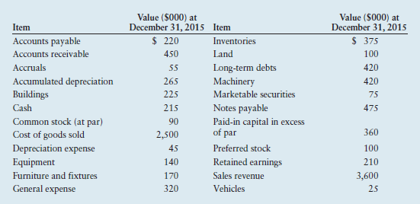

P3-10
Statement of retained earnings Hayes Enterprises began 2015 with a retained earnings balance of $928,000. During 2015, the firm earned $377,000 after taxes. From this amount, preferred stockholders were paid $47,000 in dividends. At year-end 2015, the firm’s retained earnings totaled $1,048,000. The firm had 140,000 shares of common stock outstanding during 2015.

a. Prepare a statement of retained earnings for the year ended December 31, 2015,
for Hayes Enterprises. (Note: Be sure to calculate and include the amount of cash
dividends paid in 2015.)

b. Calculate the firm’s 2015 earnings per share (EPS).

c. How large a per-share cash dividend did the firm pay on common stock during
2015?

P3-16
Accounts receivable management An evaluation of the books of Blair Supply, which follows, gives the end-of-year accounts receivable balance, which is believed to consist of amounts originating in the months indicated. The company had annual sales of $2.4 million. The firm extends 30-day credit terms.
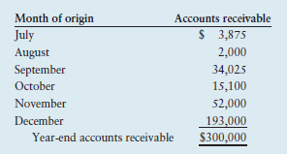
a. Use the year-end total to evaluate the firm’s collection system.

b. If 70% of the firm’s sales occur between July and December, would this information
affect the validity of your conclusion in part a? Explain.

P3-18
Debt analysis Springfield Bank is evaluating Creek Enterprises, which has requested a $4,000,000 loan, to assess the firm’s financial leverage and financial risk. On the basis of the debt ratios for Creek, along with the industry averages (see the top of the next page) and Creek’s recent financial statements (following), evaluate and recommend appropriate action on the loan request.

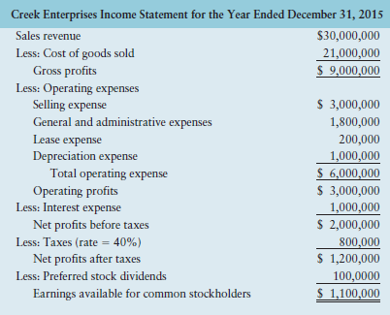

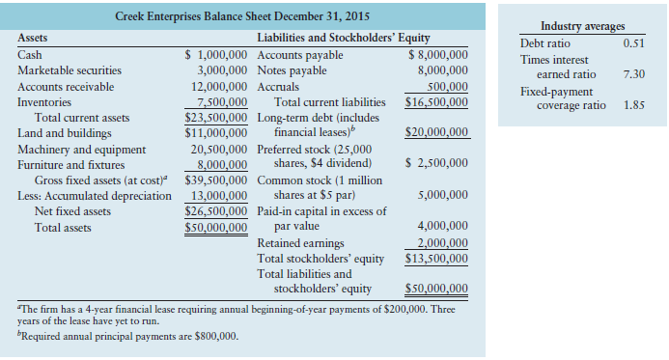

P3–20

Common-size statement analysis A common-size income statement for Creek Enterprises’ 2014 operations follows. Using the firm’s 2015 income statement presented in Problem 3–18, develop the 2015 common-size income statement and compare it with the 2014 statement. Which areas require further analysis and investigation?

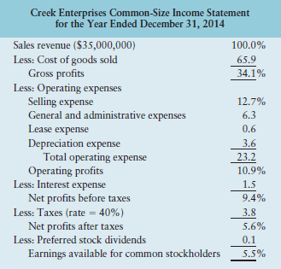
P3-21
The relationship between financial leverage and profitability Pelican Paper, Inc., and Timberland Forest, Inc., are rivals in the manufacture of craft papers. Some financial statement values for each company follow. Use them in a ratio analysis that compares the firms’ financial leverage and profitability.

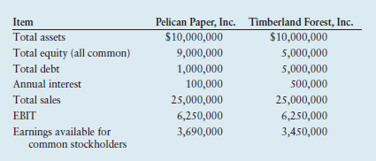

a. Calculate the following debt and coverage ratios for the two companies. Discuss
their financial risk and ability to cover the costs in relation to each other.
1. Debt ratio
2. Times interest earned ratio

b. Calculate the following profitability ratios for the two companies. Discuss their
profitability relative to one another.
1. Operating profit margin
2. Net profit margin
3. Return on total assets
4. Return on common equity

c. In what way has the larger debt of Timberland Forest made it more profitable
than Pelican Paper? What are the risks that Timberland’s investors undertake
when they choose to purchase its stock instead of Pelican’s?

